**Step 1**

**1. Microsoft Stock Data**

**1.1 Identifying Data Sources**

Download the equities time series data for the analysis of Microsoft stock data from 2019 to September 2022 using the yfinance library, considering the returns.

**1.2 Yahoo Finance**

This will download the stock price history of Microsoft from Yahoo Finance, and then it will calculate daily return using percent changes for a date range from January 1, 2019, through September 30, 2022.

**Step 2**

**2a-Regime Change Visualization Microsoft Dataset**

**Visualize the Series:** Plot the closing prices and returns to identify any possible regime changes using python coding.

**Regime Change Detection:** Clearly identify significant changes in either trend or volatility, with an emphasis on what has happened around the COVID-19 pandemic.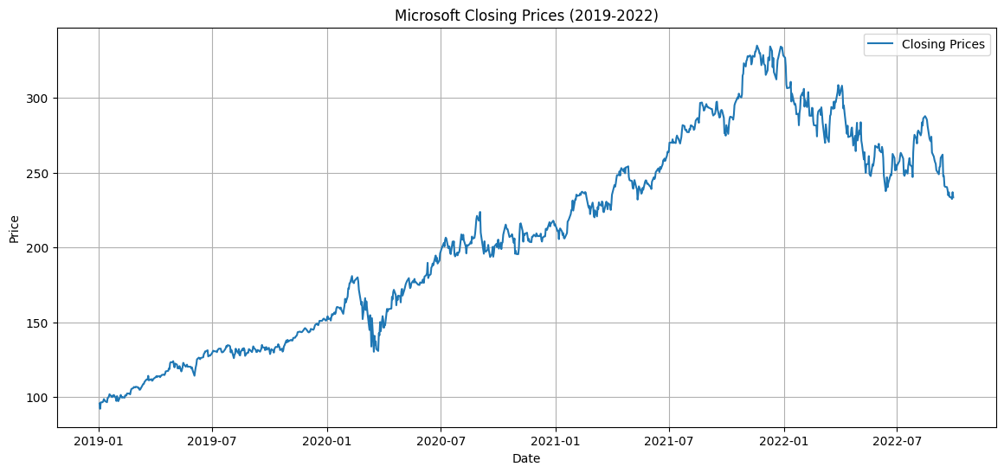

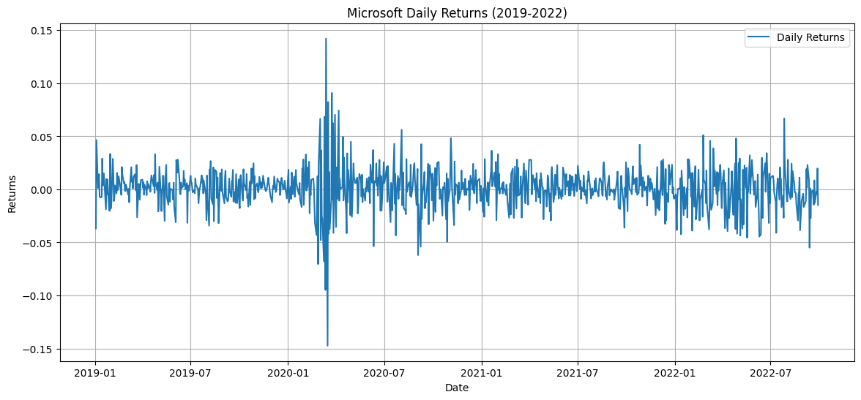

The regime changes identified from the graphs are as follows:

* Prices of Microsoft significantly went down at the beginning of 2020, rapidly recovered to peak in mid-2021, and may have started a downtrend in 2022.
* The volatility of Microsoft Daily Returns was very high in early 2020 because of the COVID-19 crisis; afterward, this stock showed high volatility during 2021-2022, a signal that there has been a market correction or some reactions due to economic news.

**2b. Estimate of a Markov-regime switching model**

In this respect, the analysis focused on the financial time series of daily returns from Microsoft for the period 1 January 2019 to 30 September 2022. The idea was estimating a Markov-regime-switching model such that regime changes in the time series are accommodated. Key findings from the estimations of the models include:

**i) Different Number of States**: two states are used to capture distinct market conditions or high-low volatility periods and, therefore each state may represent different market regimes, such as growth and contraction phases.

**ii) Different Expectations (Mus) with Constant Variance:** the model allows for different expected returns in each state while keeping variance constant, potentially reflecting shifts in average market performance. The AIC/BIC values may improve compared to other models, indicating better fit for mean shifts. Lower AIC values indicate a better fit, considering the number of parameters and BIC similar to AIC, but penalizes model complexity more strongly.

**iii) Different Variances ( Sigmas ) with Constant Expectation:** The modelled behaviour reflects different levels of market risk while assuming that the average return remains constant. Comparison through AIC/BIC tests whether the capture in volatility changes improves the fit.

**iv.** Different Expectations and Variances: It views regime switches rather comprehensively to mean and variance changes in the model and is bound to give a best fit because of flexibility.

**Conclusion**

The study therefore proposes the use of AIC and BIC in comparing the models, with their lower values indicating better fit. This, it notes, is essential for understanding such regimes for informed investment decisions.

**Step 3: Model Comparison**

**Introduction**

Performances of different Markov regime-switching models applied to the returns time series of AAPL. The standard information criteria used to compare models include Akaike Information Criterion and Bayesian Information Criterion.

**2. Member B: Models with Different Sigma Values**

**Result Summary**

**Model with Constant Sigma (Same "Mu")**

* Assumption: Variance remains the same across different states.
* AIC: 2686.118
* BIC: 2710.363

**Model with Different Sigma - Constant "Mu"**

* Assumption: The variances change across states and reflect regime switches in volatility.
* AIC: 2425.336
* BIC: 2454.430

**Analysis**

The analysis of Markov-Regime Switching Models suggests that models based on another assumption of sigma are likely to be better at describing market dynamics. Model 1 assumes only one constant level of sigma-it means a stable level of risk-while Model 2 allows for shifts in volatility to reflect changes in regime. A model with change in sigma is preferable too because it has better scores of information criteria, which means a higher fidelity of its model description of financial-market behavior.